

Removable Pressure Transducer Calibration Tool Operation Manual

|  |  |
| --- | --- |
| Document ID | MANUAL-1899207337-22 issue: 1.0 |
| Date: | March 2021 |

This confidential document was prepared by the staff of Valeport Limited, the Company, and is the property of the Company, which also owns the copyright therein. All rights conferred by the law of the copyright and by virtue of international copyright conventions are reserved to the Company. This document must not be copied, reprinted or reproduced in any material form, either wholly or in part, and the contents of this document, and any method or technique available there from, must not be disclosed to any other person whatsoever without the prior written consent of the Company.

© 2021 Valeport Ltd

|  |  |  |
| --- | --- | --- |
| Valeport Ltd  St Peter's Quay  Totnes TQ9 5EW  United Kingdom | Phone:  email:  Web: | +44 1803 869292  sales@valeportwater.co.uk  www.valeportwater.co.uk |

As part of our policy of continuous development, we reserve the right to alter, without prior notice, all specifications, designs, prices and conditions of supply for all our equipment

Contents

1. Removable Pressure Transducer Calibration Tool 1

2. Introduction 2

3. Connecting 2

4. On-board Data 2

5. Settings 3

6. Graphing 3

7. Logging & Calibration 4

## Removable Pressure Transducer Calibration Tool

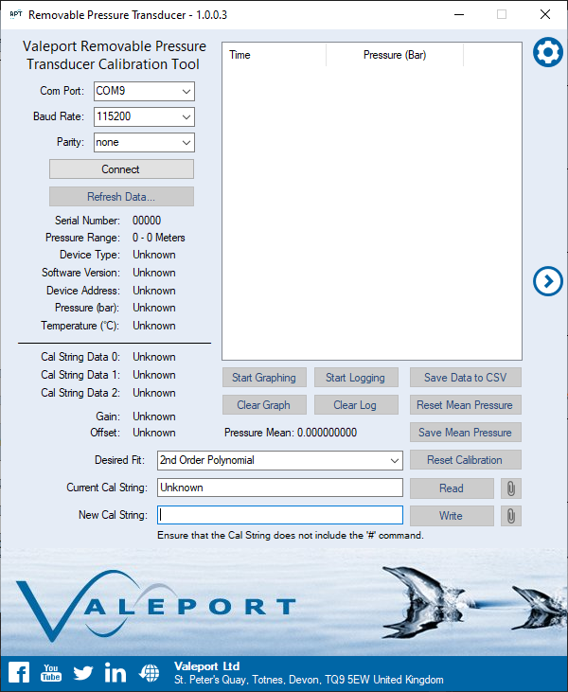

## Introduction

The Valeport Removable Pressure Tranducer Calibration Tool is designed to allow users to read and write the calibration string of their Removable Pressure Transducer.

The application can also aid in the calibration process, allowing the sensor’s data to be logged and graphed to produce a mean pressure that can be used on the calibration sheet.

Valeport’s Removable Pressure Transducer is designed for the uvSVX2 & miniIPS2, allowing customers to switch the pressure sensors for different scenarios & different pressure ranges, without having to change the instrument.

The Valeport Removable Pressure Tranducer Calibration Tool can be found on the Valeport Downloads page: <https://valeport.download/> under the instrument type’s uvSVX2 & miniIPS2.

## Connecting

Ensure that the sensor is connected with the supplied USB lead & that the sensor is facing down to verify that the weight of the diaphragm is not affecting the readings.

Connect to the sensor using the connection panel, by default: 115200, None.

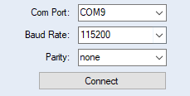

## On-board Data

Once connected, the software will automatically execute a series of commands interrogating the sensor, populating data such as the sensor’s pressure range, as well as the existing calibration.

This data can be refreshed using the ‘Refresh Data…’ button.

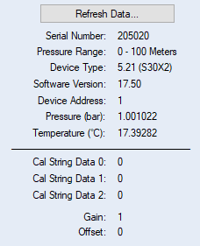

## Settings

The Settings button can be pressed to display a limited amount of user settings.

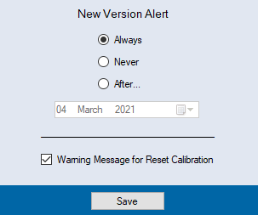

The New Version Alert will automatically inform the user when an update for the software is available, in the event that an update is released it is strongly recommended to update; various versions will be available on our downloads page: <https://valeport.download>

There is also a warning message that will appear when the ‘Reset Calibration button’ is pressed, to confirm the selection, this warning message can be disabled by unchecking the ‘Warning Message for Reset Calibration’ checkbox.

## Graphing

The Arrow buttons can be pressed to Expand or Collapse the application, displaying the graph. The graph should be used to ensure that the sensor has settled to the set pressure & to visually identify any anomalies (a spike/jump) in the data.

## Logging & Calibration

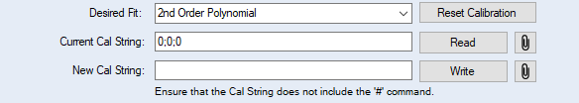

There are two different calibration options for the Removable Pressure Sensor, a Straight Line Fit & a 2nd Order Polynomial.



* A Straight Line Fit calibration will make use of the Gain & Offset values. 
* A 2nd Order Polynomial calibration will make use of the Cal String Data 0, 1, 2 parameters.



Before performing any changes to your Calibration it is recommended to save the existing Straight Line Fit & 2nd Order Polynomial values.

To start a Calibration, you must remove any existing Calibration, using the ‘Reset Calibration’ button.

(See Settings to remove the warning)

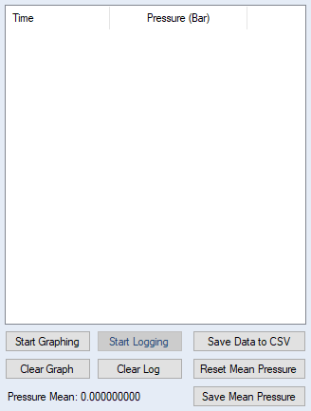

You can then click the ‘Start Graphing’ button, which will start plotting data on the graph, once the sensor has visually settled to the set weight/pressure the ‘Start Logging’ button can be pressed.

This will then log all recorded data to the list, and automatically creates a Mean for the Pressure. After recording pressures for the desired time at the desired pressure, the ‘Stop Logging’ & ‘Stop Graphing’ buttons should be pressed.

The ‘Save Mean Pressure’ button can then be pressed, this will copy the Pressure Mean value to your clipboard. Alternately, the data can be saved to a CSV file and you can calculate the mean there (It is recommended to save CSV files when the data has been used as this can be used to assist in the event of any issues).

The Mean Pressure value can then be pasted into the Raw Output cell of the provided Calibration Sheet (Excel) next to the appropriate deadweight value.

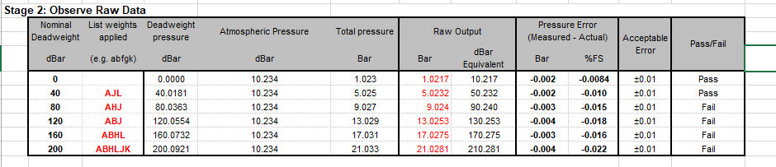

You can then change the weight of the deadweight tester, **reset** the Mean Pressure value & Graph and clear the Log before repeating the process for the next weight.

Once all weights are complete you can be compare the Pressure Error values to the Acceptable Error value, this is determine if the recorded Mean Pressure for the specific weight has passed or failed.

The calibration sheet will then produce a Gain/Offset command for a Straight Line Fit or a 3 Parameter command for a 2nd Order Polynomial, additionally informing you which fit to you should use.

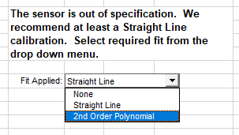

This command can then be copied back to the Removable Pressure Transducer application and pasted into the ‘New Cal String’ or ‘New Gain/Offset’ fields, ensuring that the ‘#’ command has been removed. The ‘Write’ button can then be clicked to execute the command to the sensor.